4/5/2022

Mc Shane Jack

LYIT

Experiment Portfolio – Craignahorna 4

RIVERS Project

Contents

1. Procedure 2

2. Experiment Apparatus (Insert Pictures When Carried out) 3

3. Time 1 – 11.00am 4

3.1. Experiment 1 4

3.1.1. Plastic Bottle 4

3.1.2. Plastic Bottle 5

3.1.3. Plastic Bottle 6

3.1.4. Plastic Coloured Bottle 7

3.1.5. Plastic Coloured Bottle 8

3.1.6. Plastic Coloured Bottle 9

3.1.7. Plastic Clear Bag 10

3.1.8. Plastic Clear Bag 11

3.1.9. Plastic Clear Bag 12

3.1.10. Plastic Coloured Bag 13

3.1.11. Plastic Coloured Bag 14

3.1.12. Plastic Coloured Bag 15

4. Time 3 – 7.30pm 16

4.1. Experiment 3 16

4.1.1. Plastic Bottle 16

4.1.2. Plastic Bottle 17

4.1.3. Plastic Bottle 18

4.1.4. Plastic Coloured Bottle 19

4.1.5. Plastic Coloured Bottle 20

4.1.6. Plastic Coloured Bottle 21

4.1.7. Plastic Clear Bag 22

4.1.8. Plastic Clear Bag 23

4.1.9. Plastic Clear Bag 24

4.1.10. Plastic Coloured Bag 25

4.1.11. Plastic Coloured Bag 26

4.1.12. Plastic Coloured Bag 27

# Procedure

* Identify rivers and streams for testing.
* Create test waste objects.
  + Plastic Clear Bottle
  + Plastic Labelled Bottle
  + Clear Plastic Bag
  + Coloured Plastic Bag
  + Tin Can
* When on location, document test information.
* Mark camera area for testing.
* Start camera recording, taking a snapshot of each piece of waste.
* Release waste and collect once it has passed.
* Repeat three times at each location
* Estimated Times*
  + 10.00 am
  + 3.00 pm
  + 7.30 pm

# Experiment Apparatus (Insert Pictures When Carried out)

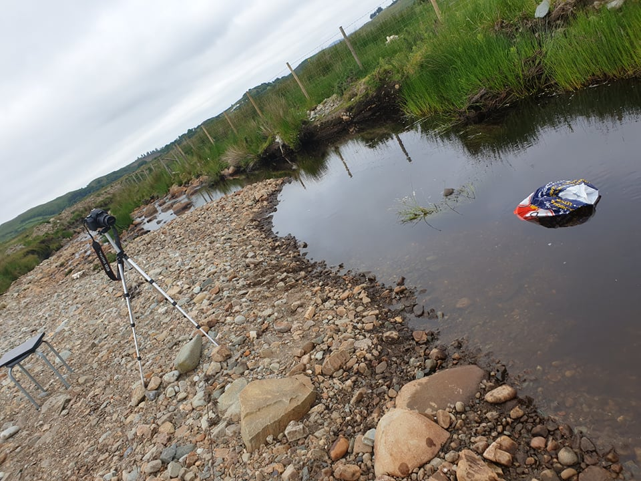

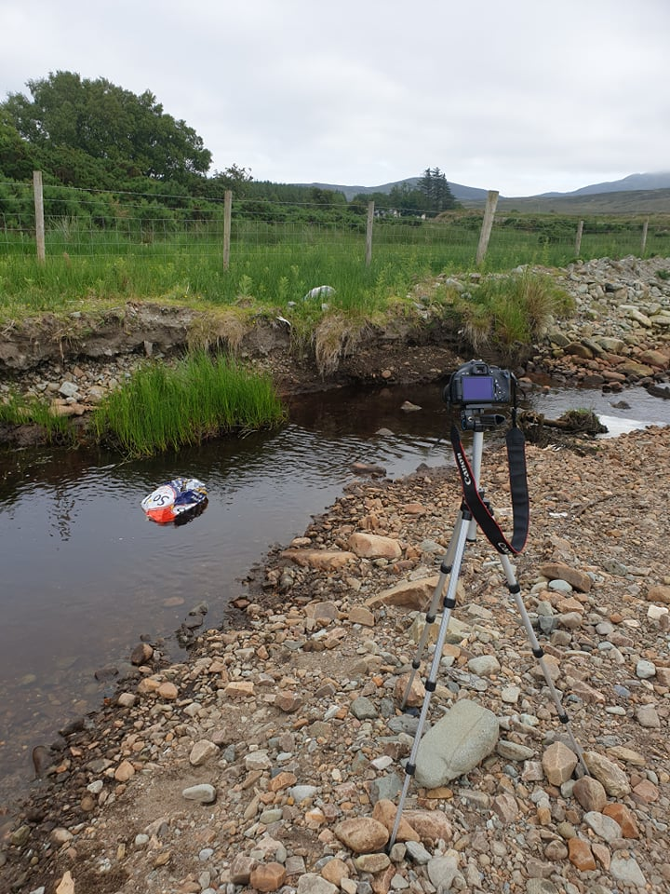

# Time 1 – 11.00am

## Experiment 1

### Plastic Bottle

|  |  |
| --- | --- |
| Name: | Jack McShane |
| Project: | RIVERS: Real-Time Identification of Various Environmental Pollutants in Rivers |
| Test Number: | 1 |

|  |  |
| --- | --- |
| **Test Number** | **1** |
| Weather Conditions | Rain and Dull |
| Light Conditions | Bright, FC = 1954 |
| Date | 05/01/2022 |
| Vegetation | Stoney, Mossy |
| Season | Spring |
| Humidity | 92% |
| Time of Day | Noon |
| Wind Speed | 37 km/h |
| Water Speed and Depth | 5 Knot, 4 ft deep |
| Waste Type | Rubbish |
| River Location and Name | Craignahorna |
| Water Clarity | Foggy |
| Tidal | Bog Stream |
| Angle of Sun | N/A |
| Capture Mode | DSLR |
| Duration | 1 hr |
| River/Stream Width | 4 Metres |
| Temperature | 9 Degrees |

### Plastic Bottle

|  |  |
| --- | --- |
| Name: | Jack McShane |
| Project: | RIVERS: Real-Time Identification of Various Environmental Pollutants in Rivers |
| Test Number: | 2 |

|  |  |
| --- | --- |
| **Test Number** | **2** |
| Weather Conditions | Rain and Dull |
| Light Conditions | Bright, FC = 1976 |
| Date | 05/01/2022 |
| Vegetation | Stoney, Mossy |
| Season | Spring |
| Humidity | 92% |
| Time of Day | Noon |
| Wind Speed | 37 km/h |
| Water Speed and Depth | 5 Knot, 4 ft deep |
| Waste Type | Rubbish |
| River Location and Name | Craignahorna |
| Water Clarity | Foggy |
| Tidal | Bog Stream |
| Angle of Sun | N/A |
| Capture Mode | DSLR |
| Duration | 1 hr |
| River/Stream Width | 4 Metres |
| Temperature | 9 Degrees |

### Plastic Bottle

|  |  |
| --- | --- |
| Name: | Jack McShane |
| Project: | RIVERS: Real-Time Identification of Various Environmental Pollutants in Rivers |
| Test Number: | 3 |

|  |  |
| --- | --- |
| **Test Number** | **3** |
| Weather Conditions | Rain and Dull |
| Light Conditions | Bright, FC = 1986 |
| Date | 05/01/2022 |
| Vegetation | Stoney, Mossy |
| Season | Spring |
| Humidity | 92% |
| Time of Day | Noon |
| Wind Speed | 37 km/h |
| Water Speed and Depth | 5 Knot, 4 ft deep |
| Waste Type | Rubbish |
| River Location and Name | Craignahorna |
| Water Clarity | Foggy |
| Tidal | Bog Stream |
| Angle of Sun | N/A |
| Capture Mode | DSLR |
| Duration | 1 hr |
| River/Stream Width | 4 Metres |
| Temperature | 9 Degrees |

### Plastic Coloured Bottle

|  |  |
| --- | --- |
| Name: | Jack McShane |
| Project: | RIVERS: Real-Time Identification of Various Environmental Pollutants in Rivers |
| Test Number: | 1 |

|  |  |
| --- | --- |
| **Test Number** | **1** |
| Weather Conditions | Rain and Dull |
| Light Conditions | Bright, FC = 2005 |
| Date | 05/01/2022 |
| Vegetation | Stoney, Mossy |
| Season | Spring |
| Humidity | 92% |
| Time of Day | Noon |
| Wind Speed | 37 km/h |
| Water Speed and Depth | 5 Knot, 4 ft deep |
| Waste Type | Rubbish |
| River Location and Name | Craignahorna |
| Water Clarity | Foggy |
| Tidal | Bog Stream |
| Angle of Sun | N/A |
| Capture Mode | DSLR |
| Duration | 1 hr |
| River/Stream Width | 4 Metres |
| Temperature | 9 Degrees |

### Plastic Coloured Bottle

|  |  |
| --- | --- |
| Name: | Jack McShane |
| Project: | RIVERS: Real-Time Identification of Various Environmental Pollutants in Rivers |
| Test Number: | 2 |

|  |  |
| --- | --- |
| **Test Number** | **2** |
| Weather Conditions | Rain and Dull |
| Light Conditions | Bright, FC = 2014 |
| Date | 05/01/2022 |
| Vegetation | Stoney, Mossy |
| Season | Spring |
| Humidity | 92% |
| Time of Day | Noon |
| Wind Speed | 37 km/h |
| Water Speed and Depth | 5 Knot, 4 ft deep |
| Waste Type | Rubbish |
| River Location and Name | Craignahorna |
| Water Clarity | Foggy |
| Tidal | Bog Stream |
| Angle of Sun | N/A |
| Capture Mode | DSLR |
| Duration | 1 hr |
| River/Stream Width | 4 Metres |
| Temperature | 9 Degrees |

### Plastic Coloured Bottle

|  |  |
| --- | --- |
| Name: | Jack McShane |
| Project: | RIVERS: Real-Time Identification of Various Environmental Pollutants in Rivers |
| Test Number: | 3 |

|  |  |
| --- | --- |
| **Test Number** | **3** |
| Weather Conditions | Rain and Dull |
| Light Conditions | Bright, FC = 2034 |
| Date | 05/01/2022 |
| Vegetation | Stoney, Mossy |
| Season | Spring |
| Humidity | 92% |
| Time of Day | Noon |
| Wind Speed | 37 km/h |
| Water Speed and Depth | 5 Knot, 4 ft deep |
| Waste Type | Rubbish |
| River Location and Name | Craignahorna |
| Water Clarity | Foggy |
| Tidal | Bog Stream |
| Angle of Sun | N/A |
| Capture Mode | DSLR |
| Duration | 1 hr |
| River/Stream Width | 4 Metres |
| Temperature | 9 Degrees |

### Plastic Clear Bag

|  |  |
| --- | --- |
| Name: | Jack McShane |
| Project: | RIVERS: Real-Time Identification of Various Environmental Pollutants in Rivers |
| Test Number: | 1 |

|  |  |
| --- | --- |
| **Test Number** | **1** |
| Weather Conditions | Rain and Dull |
| Light Conditions | Bright, FC = 2055 |
| Date | 05/01/2022 |
| Vegetation | Stoney, Mossy |
| Season | Spring |
| Humidity | 92% |
| Time of Day | Noon |
| Wind Speed | 37 km/h |
| Water Speed and Depth | 5 Knot, 4 ft deep |
| Waste Type | Rubbish |
| River Location and Name | Craignahorna |
| Water Clarity | Foggy |
| Tidal | Bog Stream |
| Angle of Sun | N/A |
| Capture Mode | DSLR |
| Duration | 1 hr |
| River/Stream Width | 4 Metres |
| Temperature | 9 Degrees |

### Plastic Clear Bag

|  |  |
| --- | --- |
| Name: | Jack McShane |
| Project: | RIVERS: Real-Time Identification of Various Environmental Pollutants in Rivers |
| Test Number: | 2 |

|  |  |
| --- | --- |
| **Test Number** | **2** |
| Weather Conditions | Rain and Dull |
| Light Conditions | Bright, FC = 2090 |
| Date | 05/01/2022 |
| Vegetation | Stoney, Mossy |
| Season | Spring |
| Humidity | 92% |
| Time of Day | Noon |
| Wind Speed | 37 km/h |
| Water Speed and Depth | 5 Knot, 4 ft deep |
| Waste Type | Rubbish |
| River Location and Name | Craignahorna |
| Water Clarity | Foggy |
| Tidal | Bog Stream |
| Angle of Sun | N/A |
| Capture Mode | DSLR |
| Duration | 1 hr |
| River/Stream Width | 4 Metres |
| Temperature | 9 Degrees |

### Plastic Clear Bag

|  |  |
| --- | --- |
| Name: | Jack McShane |
| Project: | RIVERS: Real-Time Identification of Various Environmental Pollutants in Rivers |
| Test Number: | 3 |

|  |  |
| --- | --- |
| **Test Number** | **3** |
| Weather Conditions | Rain and Dull |
| Light Conditions | Bright, FC = 2108 |
| Date | 05/01/2022 |
| Vegetation | Stoney, Mossy |
| Season | Spring |
| Humidity | 92% |
| Time of Day | Noon |
| Wind Speed | 37 km/h |
| Water Speed and Depth | 5 Knot, 4 ft deep |
| Waste Type | Rubbish |
| River Location and Name | Craignahorna |
| Water Clarity | Foggy |
| Tidal | Bog Stream |
| Angle of Sun | N/A |
| Capture Mode | DSLR |
| Duration | 1 hr |
| River/Stream Width | 4 Metres |
| Temperature | 9 Degrees |

### Plastic Coloured Bag

|  |  |
| --- | --- |
| Name: | Jack McShane |
| Project: | RIVERS: Real-Time Identification of Various Environmental Pollutants in Rivers |
| Test Number: | 1 |

|  |  |
| --- | --- |
| **Test Number** | **1** |
| Weather Conditions | Rain and Dull |
| Light Conditions | Bright, FC = 2150 |
| Date | 05/01/2022 |
| Vegetation | Stoney, Mossy |
| Season | Spring |
| Humidity | 92% |
| Time of Day | Noon |
| Wind Speed | 37 km/h |
| Water Speed and Depth | 5 Knot, 4 ft deep |
| Waste Type | Rubbish |
| River Location and Name | Craignahorna |
| Water Clarity | Foggy |
| Tidal | Bog Stream |
| Angle of Sun | N/A |
| Capture Mode | DSLR |
| Duration | 1 hr |
| River/Stream Width | 4 Metres |
| Temperature | 9 Degrees |

### Plastic Coloured Bag

|  |  |
| --- | --- |
| Name: | Jack McShane |
| Project: | RIVERS: Real-Time Identification of Various Environmental Pollutants in Rivers |
| Test Number: | 2 |

|  |  |
| --- | --- |
| **Test Number** | **2** |
| Weather Conditions | Rain and Dull |
| Light Conditions | Bright, FC = 2170 |
| Date | 05/01/2022 |
| Vegetation | Stoney, Mossy |
| Season | Spring |
| Humidity | 92% |
| Time of Day | Noon |
| Wind Speed | 37 km/h |
| Water Speed and Depth | 5 Knot, 4 ft deep |
| Waste Type | Rubbish |
| River Location and Name | Craignahorna |
| Water Clarity | Foggy |
| Tidal | Bog Stream |
| Angle of Sun | N/A |
| Capture Mode | DSLR |
| Duration | 1 hr |
| River/Stream Width | 4 Metres |
| Temperature | 9 Degrees |

### Plastic Coloured Bag

|  |  |
| --- | --- |
| Name: | Jack McShane |
| Project: | RIVERS: Real-Time Identification of Various Environmental Pollutants in Rivers |
| Test Number: | 3 |

|  |  |
| --- | --- |
| **Test Number** | **3** |
| Weather Conditions | Rain and Dull |
| Light Conditions | Bright, FC = 2230 |
| Date | 05/01/2022 |
| Vegetation | Stoney, Mossy |
| Season | Spring |
| Humidity | 92% |
| Time of Day | Noon |
| Wind Speed | 37 km/h |
| Water Speed and Depth | 5 Knot, 4 ft deep |
| Waste Type | Rubbish |
| River Location and Name | Craignahorna |
| Water Clarity | Foggy |
| Tidal | Bog Stream |
| Angle of Sun | N/A |
| Capture Mode | DSLR |
| Duration | 1 hr |
| River/Stream Width | 4 Metres |
| Temperature | 9 Degrees |

# Time 3 – 7.30pm

## Experiment 3

### Plastic Bottle

|  |  |
| --- | --- |
| Name: | Jack McShane |
| Project: | RIVERS: Real-Time Identification of Various Environmental Pollutants in Rivers |
| Test Number: | 1 |

|  |  |
| --- | --- |
| **Test Number** | **1** |
| Weather Conditions | Rain and Dull |
| Light Conditions | Dull, FC = 178 |
| Date | 05/01/2022 |
| Vegetation | Stoney, Mossy |
| Season | Spring |
| Humidity | 92% |
| Time of Day | Evening |
| Wind Speed | 45 km/h |
| Water Speed and Depth | 5 Knot, 4 ft deep |
| Waste Type | Rubbish |
| River Location and Name | Craignahorna |
| Water Clarity | Foggy |
| Tidal | Bog Stream |
| Angle of Sun | N/A |
| Capture Mode | DSLR |
| Duration | 1 hr |
| River/Stream Width | 4 Metres |
| Temperature | 9 Degrees |

### Plastic Bottle

|  |  |
| --- | --- |
| Name: | Jack McShane |
| Project: | RIVERS: Real-Time Identification of Various Environmental Pollutants in Rivers |
| Test Number: | 2 |

|  |  |
| --- | --- |
| **Test Number** | **2** |
| Weather Conditions | Rain and Dull |
| Light Conditions | Dull, FC = 169 |
| Date | 05/01/2022 |
| Vegetation | Stoney, Mossy |
| Season | Spring |
| Humidity | 92% |
| Time of Day | Evening |
| Wind Speed | 45 km/h |
| Water Speed and Depth | 5 Knot, 4 ft deep |
| Waste Type | Rubbish |
| River Location and Name | Craignahorna |
| Water Clarity | Foggy |
| Tidal | Bog Stream |
| Angle of Sun | N/A |
| Capture Mode | DSLR |
| Duration | 1 hr |
| River/Stream Width | 4 Metres |
| Temperature | 9 Degrees |

### Plastic Bottle

|  |  |
| --- | --- |
| Name: | Jack McShane |
| Project: | RIVERS: Real-Time Identification of Various Environmental Pollutants in Rivers |
| Test Number: | 3 |

|  |  |
| --- | --- |
| **Test Number** | **3** |
| Weather Conditions | Rain and Dull |
| Light Conditions | Dull, FC = 162 |
| Date | 05/01/2022 |
| Vegetation | Stoney, Mossy |
| Season | Spring |
| Humidity | 92% |
| Time of Day | Evening |
| Wind Speed | 45 km/h |
| Water Speed and Depth | 5 Knot, 4 ft deep |
| Waste Type | Rubbish |
| River Location and Name | Craignahorna |
| Water Clarity | Foggy |
| Tidal | Bog Stream |
| Angle of Sun | N/A |
| Capture Mode | DSLR |
| Duration | 1 hr |
| River/Stream Width | 4 Metres |
| Temperature | 9 Degrees |

### Plastic Coloured Bottle

|  |  |
| --- | --- |
| Name: | Jack McShane |
| Project: | RIVERS: Real-Time Identification of Various Environmental Pollutants in Rivers |
| Test Number: | 1 |

|  |  |
| --- | --- |
| **Test Number** | **1** |
| Weather Conditions | Overcast, cloudy |
| Light Conditions | Rain and Dull |
| Date | Dull, FC = 161 |
| Vegetation | 05/01/2022 |
| Season | Stoney, Mossy |
| Humidity | Spring |
| Time of Day | 92% |
| Wind Speed | Evening |
| Water Speed and Depth | 45 km/h |
| Waste Type | 5 Knot, 4 ft deep |
| River Location and Name | Rubbish |
| Water Clarity | Craignahorna |
| Tidal | Foggy |
| Angle of Sun | Bog Stream |
| Capture Mode | N/A |
| Duration | DSLR |
| River/Stream Width | 1 hr |
| Temperature | 4 Metres |

### Plastic Coloured Bottle

|  |  |
| --- | --- |
| Name: | Jack McShane |
| Project: | RIVERS: Real-Time Identification of Various Environmental Pollutants in Rivers |
| Test Number: | 2 |

|  |  |
| --- | --- |
| **Test Number** | **2** |
| Weather Conditions | Rain and Dull |
| Light Conditions | Dull, FC = 160 |
| Date | 05/01/2022 |
| Vegetation | Stoney, Mossy |
| Season | Spring |
| Humidity | 92% |
| Time of Day | Evening |
| Wind Speed | 45 km/h |
| Water Speed and Depth | 5 Knot, 4 ft deep |
| Waste Type | Rubbish |
| River Location and Name | Craignahorna |
| Water Clarity | Foggy |
| Tidal | Bog Stream |
| Angle of Sun | N/A |
| Capture Mode | DSLR |
| Duration | 1 hr |
| River/Stream Width | 4 Metres |
| Temperature | 9 Degrees |

### Plastic Coloured Bottle

|  |  |
| --- | --- |
| Name: | Jack McShane |
| Project: | RIVERS: Real-Time Identification of Various Environmental Pollutants in Rivers |
| Test Number: | 3 |

|  |  |
| --- | --- |
| **Test Number** | **3** |
| Weather Conditions | Rain and Dull |
| Light Conditions | Dull, FC = 155 |
| Date | 05/01/2022 |
| Vegetation | Stoney, Mossy |
| Season | Spring |
| Humidity | 92% |
| Time of Day | Evening |
| Wind Speed | 45 km/h |
| Water Speed and Depth | 5 Knot, 4 ft deep |
| Waste Type | Rubbish |
| River Location and Name | Craignahorna |
| Water Clarity | Foggy |
| Tidal | Bog Stream |
| Angle of Sun | N/A |
| Capture Mode | DSLR |
| Duration | 1 hr |
| River/Stream Width | 4 Metres |
| Temperature | 9 Degrees |

### Plastic Clear Bag

|  |  |
| --- | --- |
| Name: | Jack McShane |
| Project: | RIVERS: Real-Time Identification of Various Environmental Pollutants in Rivers |
| Test Number: | 1 |

|  |  |
| --- | --- |
| **Test Number** | **1** |
| Weather Conditions | Rain and Dull |
| Light Conditions | Dull, FC = 152 |
| Date | 05/01/2022 |
| Vegetation | Stoney, Mossy |
| Season | Spring |
| Humidity | 92% |
| Time of Day | Evening |
| Wind Speed | 45 km/h |
| Water Speed and Depth | 5 Knot, 4 ft deep |
| Waste Type | Rubbish |
| River Location and Name | Craignahorna |
| Water Clarity | Foggy |
| Tidal | Bog Stream |
| Angle of Sun | N/A |
| Capture Mode | DSLR |
| Duration | 1 hr |
| River/Stream Width | 4 Metres |
| Temperature | 9 Degrees |

### Plastic Clear Bag

|  |  |
| --- | --- |
| Name: | Jack McShane |
| Project: | RIVERS: Real-Time Identification of Various Environmental Pollutants in Rivers |
| Test Number: | 2 |

|  |  |
| --- | --- |
| **Test Number** | **2** |
| Weather Conditions | Rain and Dull |
| Light Conditions | Dull, FC = 150 |
| Date | 05/01/2022 |
| Vegetation | Stoney, Mossy |
| Season | Spring |
| Humidity | 92% |
| Time of Day | Evening |
| Wind Speed | 45 km/h |
| Water Speed and Depth | 5 Knot, 4 ft deep |
| Waste Type | Rubbish |
| River Location and Name | Craignahorna |
| Water Clarity | Foggy |
| Tidal | Bog Stream |
| Angle of Sun | N/A |
| Capture Mode | DSLR |
| Duration | 1 hr |
| River/Stream Width | 4 Metres |
| Temperature | 9 Degrees |

### Plastic Clear Bag

|  |  |
| --- | --- |
| Name: | Jack McShane |
| Project: | RIVERS: Real-Time Identification of Various Environmental Pollutants in Rivers |
| Test Number: | 3 |

|  |  |
| --- | --- |
| **Test Number** | **3** |
| Weather Conditions | Rain and Dull |
| Light Conditions | Dull, FC = 147 |
| Date | 05/01/2022 |
| Vegetation | Stoney, Mossy |
| Season | Spring |
| Humidity | 92% |
| Time of Day | Evening |
| Wind Speed | 45 km/h |
| Water Speed and Depth | 5 Knot, 4 ft deep |
| Waste Type | Rubbish |
| River Location and Name | Craignahorna |
| Water Clarity | Foggy |
| Tidal | Bog Stream |
| Angle of Sun | N/A |
| Capture Mode | DSLR |
| Duration | 1 hr |
| River/Stream Width | 4 Metres |
| Temperature | 9 Degrees |

### Plastic Coloured Bag

|  |  |
| --- | --- |
| Name: | Jack McShane |
| Project: | RIVERS: Real-Time Identification of Various Environmental Pollutants in Rivers |
| Test Number: | 1 |

|  |  |
| --- | --- |
| **Test Number** | **1** |
| Weather Conditions | Rain and Dull |
| Light Conditions | Dull, FC = 142 |
| Date | 05/01/2022 |
| Vegetation | Stoney, Mossy |
| Season | Spring |
| Humidity | 92% |
| Time of Day | Evening |
| Wind Speed | 45 km/h |
| Water Speed and Depth | 5 Knot, 4 ft deep |
| Waste Type | Rubbish |
| River Location and Name | Craignahorna |
| Water Clarity | Foggy |
| Tidal | Bog Stream |
| Angle of Sun | N/A |
| Capture Mode | DSLR |
| Duration | 1 hr |
| River/Stream Width | 4 Metres |
| Temperature | 9 Degrees |

### Plastic Coloured Bag

|  |  |
| --- | --- |
| Name: | Jack McShane |
| Project: | RIVERS: Real-Time Identification of Various Environmental Pollutants in Rivers |
| Test Number: | 2 |

|  |  |
| --- | --- |
| **Test Number** | **2** |
| Weather Conditions | Rain and Dull |
| Light Conditions | Dull, FC = 138 |
| Date | 05/01/2022 |
| Vegetation | Stoney, Mossy |
| Season | Spring |
| Humidity | 92% |
| Time of Day | Evening |
| Wind Speed | 45 km/h |
| Water Speed and Depth | 5 Knot, 4 ft deep |
| Waste Type | Rubbish |
| River Location and Name | Craignahorna |
| Water Clarity | Foggy |
| Tidal | Bog Stream |
| Angle of Sun | N/A |
| Capture Mode | DSLR |
| Duration | 1 hr |
| River/Stream Width | 4 Metres |
| Temperature | 9 Degrees |

### Plastic Coloured Bag

|  |  |
| --- | --- |
| Name: | Jack McShane |
| Project: | RIVERS: Real-Time Identification of Various Environmental Pollutants in Rivers |
| Test Number: | 3 |

|  |  |
| --- | --- |
| **Test Number** | **3** |
| Weather Conditions | Rain and Dull |
| Light Conditions | Dull, FC = 130 |
| Date | 05/01/2022 |
| Vegetation | Stoney, Mossy |
| Season | Spring |
| Humidity | 92% |
| Time of Day | Evening |
| Wind Speed | 45 km/h |
| Water Speed and Depth | 5 Knot, 4 ft deep |
| Waste Type | Rubbish |
| River Location and Name | Craignahorna |
| Water Clarity | Foggy |
| Tidal | Bog Stream |
| Angle of Sun | N/A |
| Capture Mode | DSLR |
| Duration | 1 hr |
| River/Stream Width | 4 Metres |
| Temperature | 9 Degrees |